1. **INTRODUCTION**
   1. **OVERVIEW**

**Smart Card Technology** is an application wherein a secure transaction can be made for credits or a debit transaction can be made. In this application the user is provided with a password to view his own account details .The card produced by this application can be used as multi-tasking card. It maintains connection with a MySql database while updating records and updating them. This gives it a practical approach towards functioning.

**1.2 EXISTING SYSTEM:**

Existing system of smart card system consists of normal swiping and updating of information into the database where the user can’t see his whole account details which the sales person gives him. Also the transaction is not 100% guaranteed whether the transaction is secured or not. Smart card technology is applied to various cards nowadays such as debit, credit, master cards etc.

**1.3 PROPOSED SYSTEM:**

By this project we can create a card which has all the features in it i.e. the features of debit, credit card etc. in one card. With only one swipe we can update the information check the information and also retrieve information with much security. This helps everyone to save much time and many cards and preventing many passwords (pin numbers).

In this project we make a java application and connect it with the database using sql. Initially we need to enter the pin no. to retrieve or update for any details.

**1.4 AIM OF THE PROJECT**

We have tried to present a holistic approach to this process by implementation of Swings concepts which makes it easier to grasp the subject matter and work upon it. Consequently, the operations can be done within the same domain thus making the entire process incredibly lucid and plausible.

**1.5 ORGANIZATION OF REPORT**

The organization of the report is as follows:

**Chapter 1** deals with the Introduction of the project and gives the details about the project in an abstract view.

**Chapter 2** deals with the Software Requirements Specifications which is a specification of the project software and hardware requirements.

**Chapter 3** deals with the System Requirements Specifications which comprises of web pages, languages in use and their explanation.

**Chapter 4** deals with the Implementation part which includes the technologies that are used and the codes that have been implemented.

**Chapter 5** deals with the Conclusion and Future works

**Chapter 6** explains the bibliography

**2. SOFTWARE REQUIREMENTS AND SPECIFICATIONS**

The requirements specification is a technical specification of requirements for the software products. It is the first step in the requirements analysis process it lists the requirements of a particular software system including functional, performance and security requirements. The requirements also provide usage scenarios from a user, an operational and an administrative perspective. The purpose of software requirements specification is to provide a detailed overview of the software project, its parameters and goals. This describes the project target audience and its user interface, hardware and software requirements. It defines how the client, team and audience see the project and its functionality.

**2.1 LANGUAGE:**

**2.1.1 ADVANCED JAVA (SWINGS):**

Java is an object-oriented programming language with a built-in application programming interface (API) that can handle graphics and user interfaces and that can be used to create applications or applets. Because of its rich set of API's, similar to Macintosh and Windows, and its platform independence, Java can also be thought of as a platform in itself. Java also has standard libraries for doing mathematics.

Much of the syntax of Java is the same as C and C++. One major difference is that Java does not have pointers. However, the biggest difference is that you must write object oriented code in Java. Procedural pieces of code can only be embedded in objects. In the following we assume that the reader has some familiarity with a programming language. In particular, some familiarity with the syntax of C/C++ is useful.

In Java we distinguish between applications, which are programs that perform the same functions as those written in other programming languages, and applets, which are programs that can be embedded in a Web page and accessed over the Internet. Our initial focus will be on writing applications. When a program is compiled, a byte code is produced that can be read and executed by any platform that can run Java.

**2.2 Non-Functional Requirements**

**Performance requirements:** The system should be fast and must produce accurate results.

**Reliability:** The system should be reliable enough such that different interfaces are provided for different users based on their responsibilities.

**Maintainability:** The system will be designed as a closed system. New methods can be added easily with little or no changes in the existing architecture.

**Security:** The system should be secure that can accomplished by providing login option for the different types of users.

**System Integrity:** The power functioning of hardware and programs, appropriate physical security and safety against external threats such as eavesdropping and wiretapping.

**Privacy:** Defines the rights of the user or organizations to determine what information they are willing to share with or accept from others and how the organization can be protected against unwelcome, unfair or excessive dissemination of information about it.

**Confidentiality:** It is a special status given to sensitive information in a database to minimize the possible invasion of privacy. It is an attribute of information that characterizes its need for protection.

**2.3 DATABASE:**

The database has become an integral part of almost every human's life. Without it, many things we do would become very tedious, perhaps impossible tasks. Banks, universities, and libraries are three examples of organizations that depend heavily on some sort of database system. On the Internet, search engines, online shopping, and even the website naming convention (http://www...) would be impossible without the use of a database. A database that is implemented and interfaced on a computer is often termed a database server.

One of the fastest SQL (Structured Query Language) database servers currently on the market is the MySQL server, developed by T.c.X. DataKonsultAB.   
These capabilities range across a number of topics, including the following:

1. Ability to handle an unlimited number of simultaneous users.
2. Capacity to handle 50,000,000+ records.
3. Very fast command execution, perhaps the fastest to be found on the market.
4. Easy and efficient user

**2.2.1 CREATE A CONNECTION TO MYSQL DATABASE:**

Before you can access data in a database, you must create a connection to the database.

In PHP, this is done with the mysql_connect () function.

**Syntax**

mysql_connect (servername, username, password);

**2.2.2 TO CREATE A DATABASE:**

CREATE DATABASE database name;

## 2.2.3 CREATE A TABLE:

The CREATE TABLE statement is used to create a table in MySQL.

Syntax

### CREATE TABLE table_name ( column_name1 data_type,column_name2 data_type,column_name3 data_type, *....* ) ;

## 2.2.4 INSERT DATA INTO A DATABASE TABLE:

The INSERT INTO statement is used to add new records to a database table.

### SYNTAX:

### INSERT INTO table_name VALUES (value1, value2, value3...);

### 2.2.5 SELECT DATA FROM A DATABASE TABLE:

The SELECT statement is used to select data from a database.

### SYNTAX:

SELECT column_name(s) FROM table_name;

## 2.2.6 DELETE DATA IN A DATABASE:

The DELETE FROM statement is used to delete records from a database table.

### SYNTAX:

### DELETE FROM table_name WHERE some_column = some_value;

**2.4 SUMMARY:**

This application can be easily implemented under various situations. We can add new features as and when we require. Reusability is possible as and when require in this application. There is flexibility in all the modules. This software is extendable in ways that its original developers may not expect. This enhances extensibility like hide data structure, avoid traversing multiple links or methods, avoid case statements on object type and distinguish public and private operations. From a proper analysis of positive points and constraints on the component, it can be safely concluded that the product is a highly efficient GUI based component. This application is working properly and meeting to all user requirements. This component can be easily plugged in many other systems.

**3. SYSTEM DESIGN SPECIFICATION**

**3.1 INTRODUCTION**

Software design sits at the technical kernel of the software engineering process and is applied regardless of the development paradigm and area of application. Design is the first step in the development phase for any engineered product or system. The designer’s goal is to produce a model or representation of an entity that will later be built. Beginning, once system requirement have been specified and analyzed, system design is the first of the three technical activities -design, code and test that is required to build and verify software.

The importance can be stated with a single word “Quality”. Design is the place where quality is fostered in software development. Design provides us with representations of software that can assess for quality. Design is the only way that we can accurately translate a customer’s view into a finished software product or system. Software design serves as a foundation for all the software engineering steps that follow. Without a strong design we risk building an unstable system – one that will be difficult to test, one whose quality cannot be assessed until the last stage.

During design, progressive refinement of data structure, program structure, and procedural details are developed reviewed and documented. System design can be viewed from either technical or project management perspective. From the technical point of view, design is comprised of four activities – architectural design, data structure design, interface design and procedural design.

The System Design Specifications provides a listing of the specifications of the system and its subsystems. It also defines, in detail, the interfaces with other systems and subsystems and the facilities to be used for accomplishing the interfaces. For each subsystem, include such information as equipment needs, support software, security, and addition and deletion records.

**3.2 PROCEDURAL DESIGN:**

**3.3.1 Database System (MYSQL):**

The database has become an integral part of almost every human's life. Without it, many things we do would become very tedious, perhaps impossible tasks. Banks, universities, and libraries are three examples of organizations that depend heavily on some sort of database system. On the Internet, search engines, online shopping, and even the website naming convention (http://www...) would be impossible without the use of a database. A database that is implemented and interfaced on a computer is often termed a database server.

.

The capabilities range across a number of topics, including the following:

•Ability to handle an unlimited number of simultaneous users.

•Capacity to handle 50,000,000+ records.

•Very fast command execution, perhaps the fastest to be found on the market.

**3.3.2 Advanced Java (Swing):-**

The various implementations of the Java Swing are embedded into the project like JButton, JTextfield and many more. This gives a better display and efficient implementation. It is imported using java.swing.* package. It is a primary widget toolkit . It is a part of the Java Foundation Classes. It is an extension to the AWT. It provides a native look and feel that emulates the look and feel of several platforms, and alos supports a pluggable look and feel that allows application to have a look and feel unrelated to the underlying platform.

Features:

1. It has many more built-in actions
2. It has increased customization of products

**4. IMPLEMENTATION**

**4.1 BUILDING JFRAMES:**

Building JFrames is much similar to creating Frames in Java. Initially few Frames are created using the Null Layout to the current Frames. Then as per the user’s choice and selection the Frames are modified with many changes such as adding few buttons, few Textfields , few password fields to them. Images are also attached to these Frames using ImageIcon class.

**4.2 JOINING AND CONNECTING JFRAMES:**

All the Frames are connected to each other. Each Frame represent’s a class in Java. Once one Frame completes its task it is made to go invisible simultaneously that Frame is made to call the object of another class which indirectly refers to another Frame. In this way visibility of many Frames can be controlled properly.

**4.3 ADDING ACTIONLISTENERS TO BUTTONS:**

Every Frame contains few buttons when clicked need to perform certain operations. Hence we add action Listeners to those buttons. That is when on clicked results in calling the object of other classes which implies creating a new frame simultaneously closing the present frame.

**4.4 CREATING NECESSARY DATABASE:**

Presently we create our own database in MySql Database where our whole data is to be stored. Respective tables corresponding to the application is also created giving proper definition to them.

**4.5 CONNECTING DATABASE TO APPLICATION:**

Database need to be connected to the application so as to retrieve or update any information that is done in the application. Connecting the Database using MySql Connector and setting the class path correctly is must for the application to run properly. Any information that is required to be fetched from the database to the application is only done if the database is connected to the application properly.

**5. RESULTS AND SCREEN SHOTS**

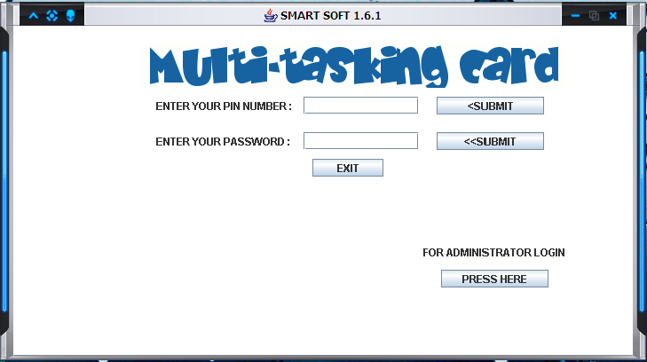 Fig: 4.1

This is home page of the application Smart Card technology. Here we have various buttons to visit next frames.

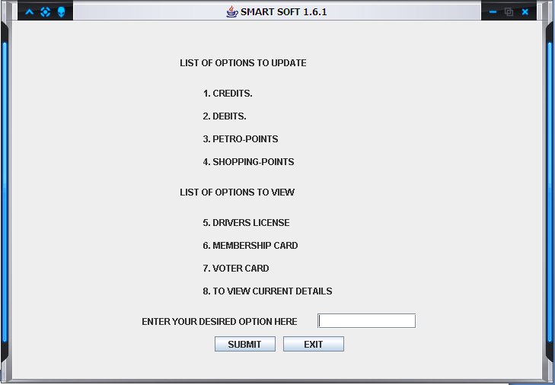

Fig: 4.2

This Frame provides the options that can be updated when the card is made to be swiped by the user.

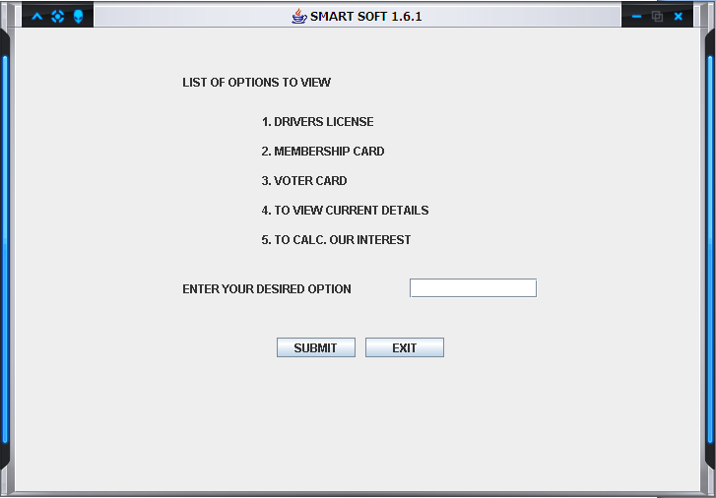

Fig: 4.3

This Frame gives the options that are displayed when the user inserts his card in the smart card reader.

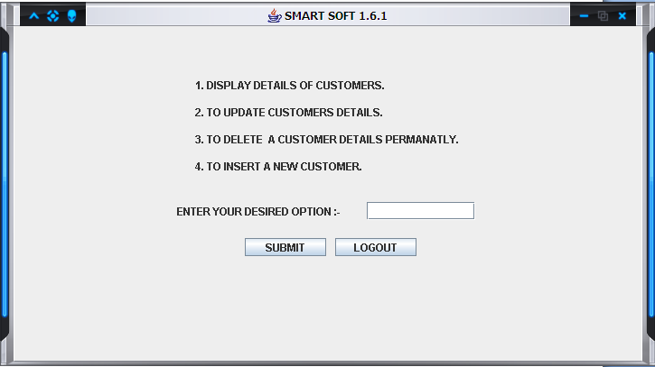

Fig: 4.4

This Frame is obtained when the admin log’s in with his user id and password.

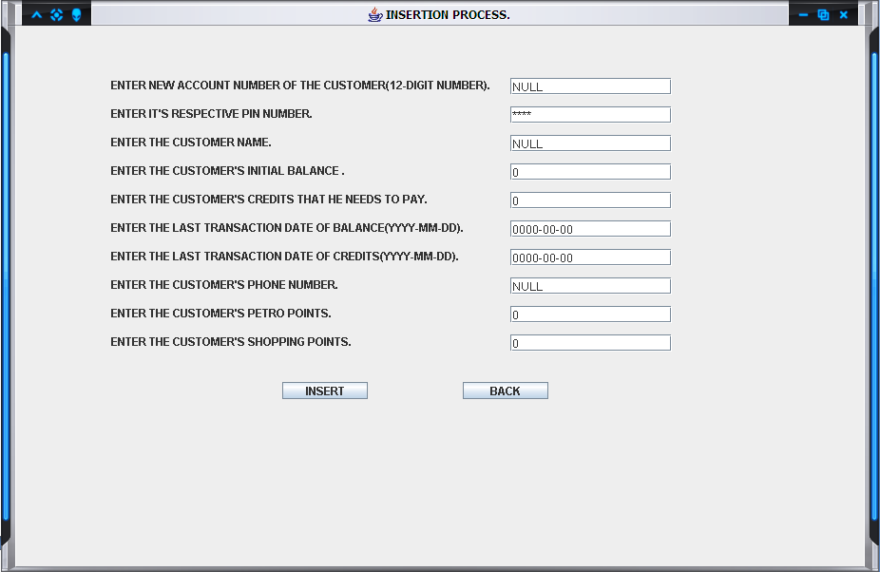

Fig: 4.5

This Frame is to insert a new customer by the admin himself.

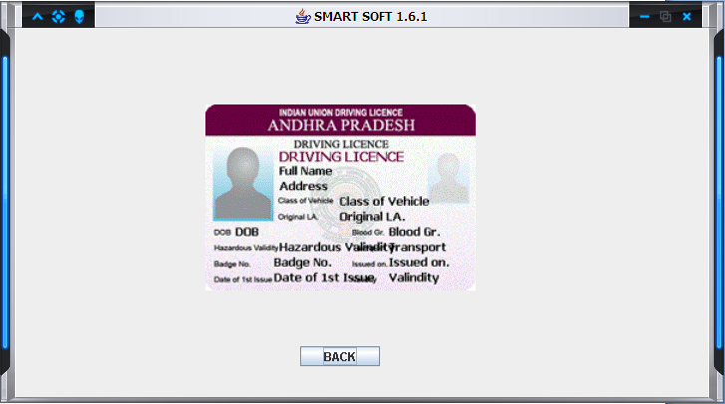

Fig: 4.6

This Frame is obtained when the user wants to view is drivers license in the smart card.

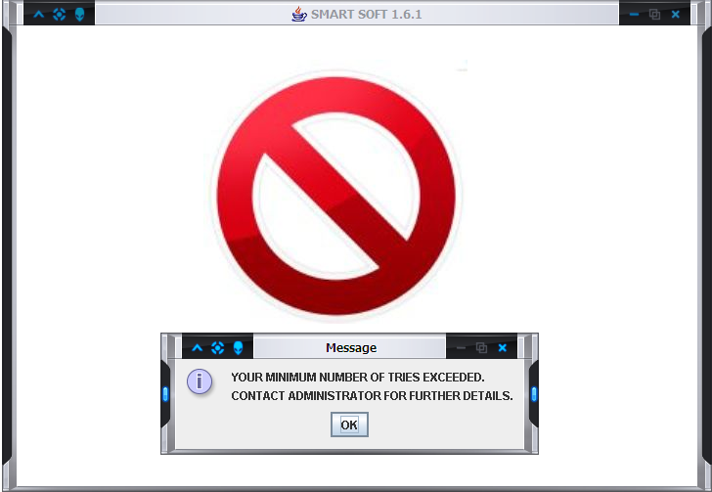

Fig: 4.7

This Frame is obtained when the minimum number of tries to login or enter the pin is exceeded by the user where the application close’s by itself.

**6. TESTING**

**5.1 LOGIN SCREEN:**

1. It has two fields: pin number & Password.

2. Pin number has to be valid ID (numeric) and password has to be matched with a stored one.

3. Upon successful login, user gains the access of system.

4. After entering Password, Submit button gets enabled.

**5.2 ALTERNATE METHOD:**

The application can be test just by retrieving the correct data from the database and without any loss in data. It can also be tested when the user updates the records and the updated data is also updated in the database. Other way is to check if the application runs only when the correct password and pin number is provided in the respective fields.

**7. CONCLUSIONS**

**SMART CARD TECHNOLOGY** will be user friendly and users will find it very useful while going through it .This project stores the account details with more security as it uses password concept particularly and it is more efficient than other.

Using Java makes the application livelier than using other languages such as c, c++, PERL etc. MySql Database serves as the backbone of this application as it provides the storage of necessary data in it. The methodology used in this application is very simple and easy to understand. The best feature is that we can update the application day to day making the application easier for many users to use it.

Lastly, mentioning the future fetched utilities of the present undertaking is a foregone conclusion since its advent in almost all spheres of modern life. Therefore, this scheme of utility needs to be updated on a frequent basis for the benefit of the society in general.

This project is useful for easy user interface. The system utilizes the powerful database management, data retrieval and data manipulation. This project provides more ease for managing the data than manually maintaining in the documents. The project is useful for saving valuable time and reduces the huge paper work.

**7. BIBILIOGRAPHY/REFERENCE**

[1] http://www.sourcecodeproject.com

[2] http://www.planet-source-code.com

[3] http://www.google.com

[4] O’Reilly Midis, Java Programming